Go to the S3 bucket and click **Create lifecycle rule**.

.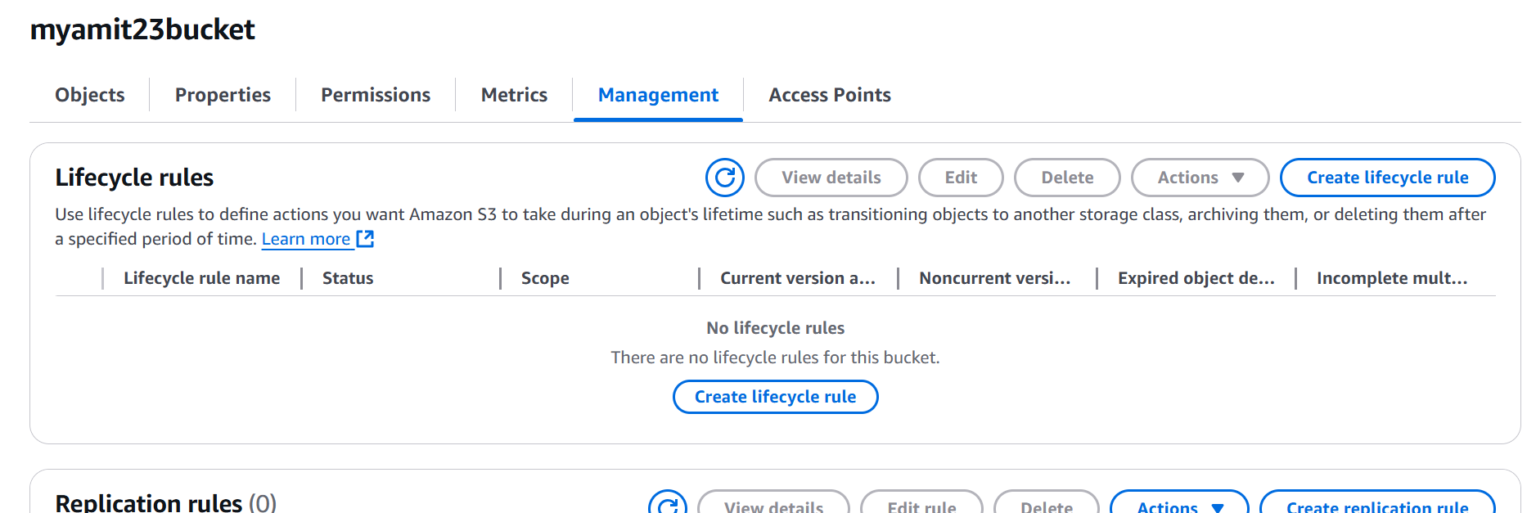

Define the lifecycle rule settings

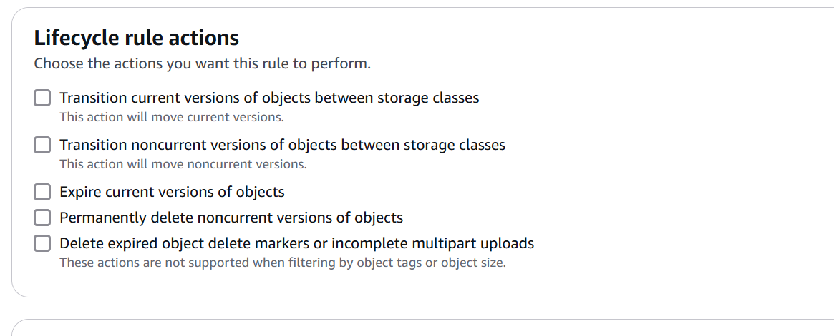

Click **Add transition** and configure transition settings.

(Optional) Add another rule if needed.

Click **Create rule** to finalize the setup. 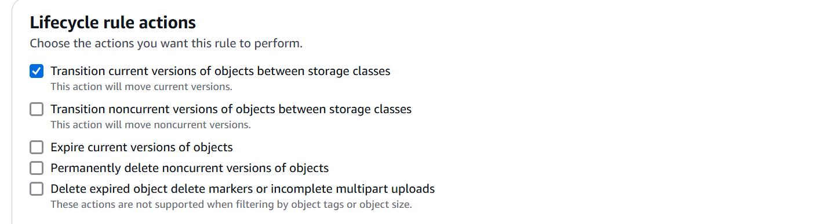

Click Transition

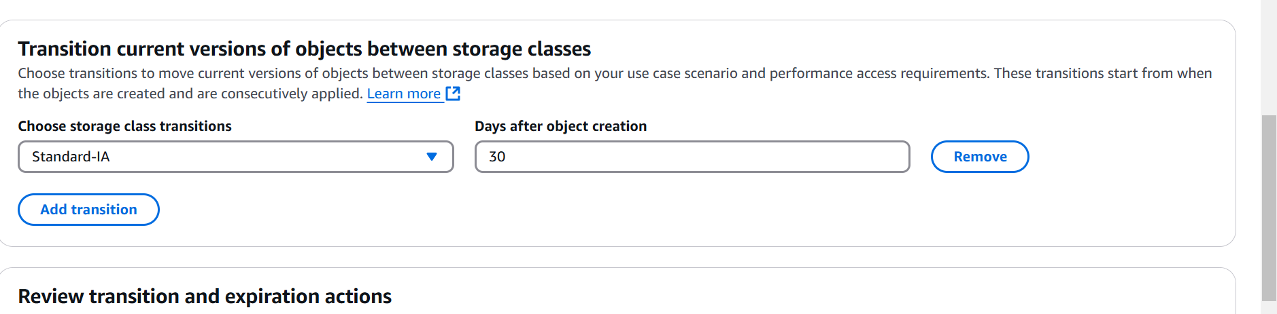

Add one more rule

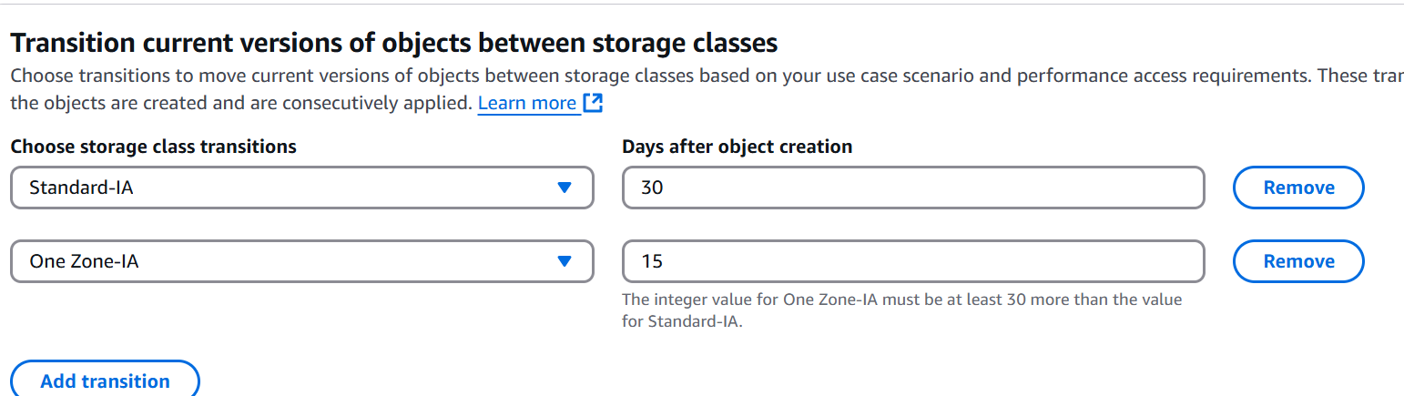

Create the rule